**Project Design Phase-II**

**Technology Stack (Architecture & Stack)**

Date

14 October 2022

Team ID

PNT2022TMID38741

Project Name

Maximum Marks

Project-Detection Parkinson’s Disease using ML

-

**Technical Architecture:**

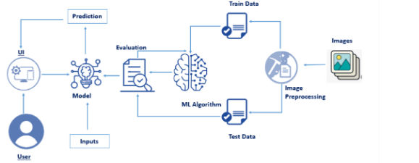

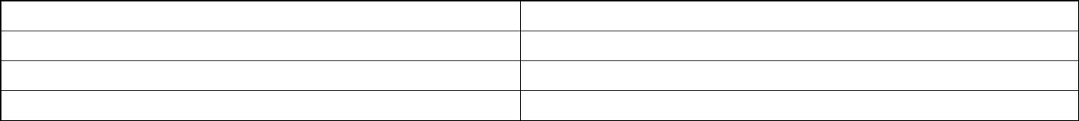

**Table-1 : Components & Technologies:**

**S.No**

**Component**

**Description**

**Technology**

1.

User Interface

How user interacts with application e.g.

Web UI

HTML, CSS, JavaScript

2.

3.

4.

5.

6.

7.

8.

9.

Application Logic-1

Application Logic-2

Application Logic-3

Database

Logic for a process in the application

Python

Logic for a process in the application

Logic for a process in the application

Data Type, Configurations etc.

IBM Watson STT service

IBM Watson Assistant

MySQL

Cloud Database

File Storage

Database Service on Cloud

IBM DB2

File storage requirements

Local Filesystem

Aadhar API

External API

Purpose of External API used in the application

Purpose of Machine Learning Model

Application Deployment on Local System / Cloud

Machine Learning Model

Random Forest classifier

10. Infrastructure (Server / Cloud)

Local Server Configuration: Local

System

Cloud Server Configuration: IBM

Watson

**Table-2: Application Characteristics:**

**S.No Characteristics**

**Description**

**Technology**

1.

2.

Open-Source Frameworks

Security Implementations

List the open-source frameworks used

List all the security / access controls implemented, Encryptions, Decryptions

use of firewalls etc.

Flask, Scikit learn, Tensor flow

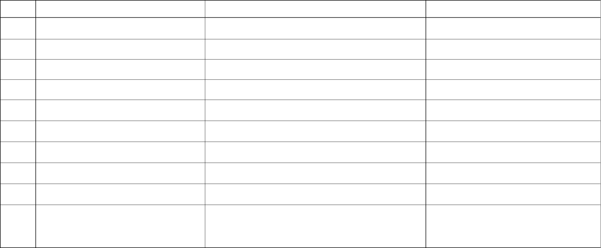

**S.No Characteristics**

**Description**

**Technology**

3.

4.

5.

Scalable Architecture

Availability

Justify the scalability of architecture (3 – tier,

Micro-services)

MySQL – As it can store huge amount

of data

IBM Watson – Can easily be accessed

Justify the availability of application (e.g. use of

load balancers, distributed servers etc.)

Design consideration for the performance of the

application (number of requests per sec, use of

Cache, use of CDN’s) etc.

Performance

Flask – Handle multiple requests

